Viva Children @ Risk Network, Patna (India)
City-wide event on safety of Girls on the occasion of
International Day of the Girl Child

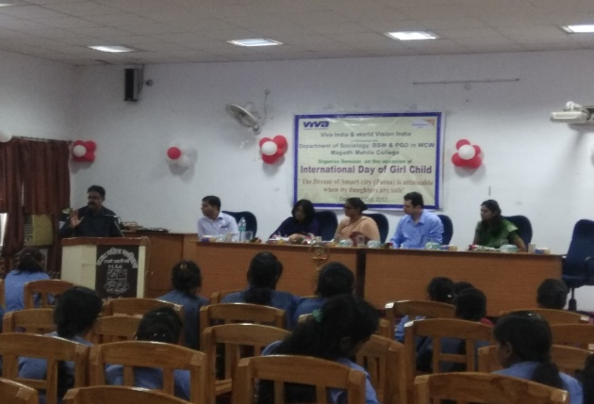
On 11th October 2017, around 200 students along with University Professors and teachers, representatives of legal fraternities, local NGOs and local administration participated in a city-wide event in Patna to raise awareness and make a commitment to prevent abuse of girls in the city.

The event has increased the profile of the need to improve protection of girls in the city, and inspired many girls to speak out about abuse and want to join the movement for change. Resolutions passed will help to provide a strong direction in which to act to have a lasting impact.

Highlights from the event
The event was opened with a motivational song presented by Viva Patna Network’s Coordinators to encourage attendees to see that its time for girls to stand up against all discrimination and together fight to make the world a better and safer place for girls.
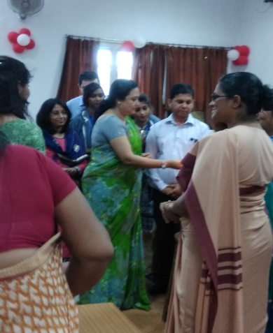
City and national leaders spoke in support of the campaign including Mrs Poonam Sinha, the child protection officer for the state of Bihar and deputy Director of the Department of Social Welfare, Government of Bihar.

Mr Suresh Kumar, who has recently headed a National study on Girl Child abuse shared the outcome of his study and emphasized the need to make efforts to provide proper safety and security to the daughters of Patna.

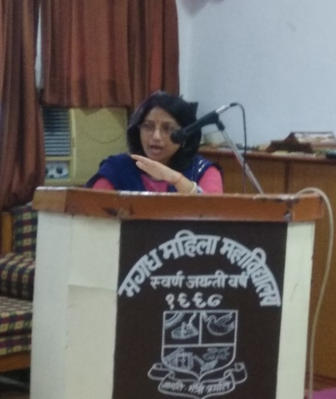
Many Girls came forward to share their ordeals and expressed their happiness for this event. Some girls alleged that police force instead of providing relief to victims of inappropriate sexual remarks and abuse usually mock them and refuse to register their complaints. Girls were coming one by one to share their struggles. They said that it is for the first time we had received a platform to speak about their ordeals. As a result of this event, they would like to be part of any movement or program which will be initiated by this forum.

Mrs. Poonam Sinha, said that though a number of students came forward to share their stories she is sure every girl present in this program is being subjected to some or other kind of teasing or abuse. She said she herself was subjected to abuse when she was a student. She promised all support for this initiative.

Viva Network Consultant, Devesh Lal closed the event by presenting the following resolutions, unanimously ratified by everyone present:
- That a girl help line number will be activated. A petition signed by 5,000 girls will be presented to the Director General of Police.
- Clubs for girls to be started in community and in educational institutions.
- Drivers of public transport like autos and buses be sensitized and made to commit to provide safety to girl passenger. Malls and shops should carry messages on safety of girls.
- Police force to be made more sensitive to the issues of girls and made more proactive through appropriate training.

